The Rules
2. No smoking in the theater (If you're just flaming, join cast).
2. This is an audience participation movie...
2. Do not throw anything at the stage, the screen, or the thespians.
2. If you have a penis, use the men's room. If you have a vagina, use the ladies room. If you've got both, piss on Wade.
2. No double sitting in the seats.
2. This is an Rated-R movie. That means, if you're easily offended, we've got five words for you: Get The Fuck Out, Bitch.

Buy This Stuff
Buttons *coming soon!!! $1.00
Prop Kits $1.00
Pic of the week
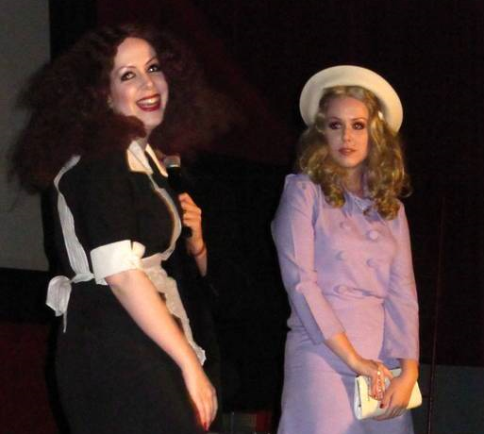
We gots twins!!!

Regency South Coast Village Theater
c/o Midnight Insanity
1561 Sunflower Avenue
Santa Ana, CA 92704
www.midnightinsanity.org

© Copyright Midnight Insanity Entertainment 1988-2010 and beyond

The Rocky Horror Picture Show
Presented by
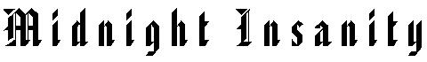

12/04/2010


